**The Tuckman Model of Team Development**

Revised Version: Arfaz Hossain

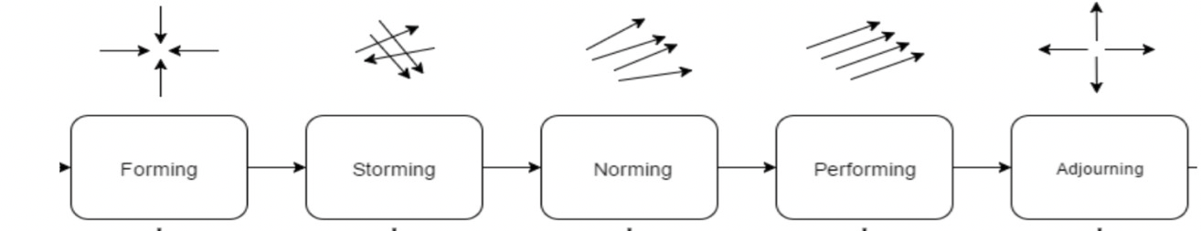The Tuckman Model, proposed by Bruce Tuckman in 1965, describes 5 stages of team development: the **forming**, **storming**, **norming**, **performing**, and the **adjourning** stage. These stages may appear to be linear, but they can be quite iterative. Teams can move back and forth between the stages, such as, during events like addition of a new team member or lack of effective communication between team members. Stalling in one stage for too long may cause a team to never realize the absolute full and complete potential of reaching the performing stage.

The **forming** stage happens when everyone in the team gets to know each other. *Creating a Team Charter* and setting the *guidelines, expectations and boundaries* can be a good strategy for everyone in the team during this stage. Engaging in a fun team forming activity can help the team in getting to know the different strengths and weaknesses of everyone in the team.

A team is in the **storming** stage, if it experiences conflict among the team members due to changes in expectations set in in the **forming** stage. When everyone in the team tries to contribute differently through competing to push for potential ideas or, while trying to determine their role in the team, conflict may arise among team members. Engaging in the process of learning to harness the constructive potential of conflict and compromise in this stage can help the team to progress to the next stage early.

During the **norming** stage, conflicts tend to be resolved among team members, as everyone start to work on their part in the team. People sometimes work independently, while checking in with teammates frequently to maintain an effective and efficient workflow of the project. Group cohesion ensures everyone to feel responsible to the task and to each other. Team development might move backwards to **forming** or **storming** stage, if teammates fail to act according to their role, or fail to follow the team expectations and the overall team goal.

A team working together for the first time might fail to reach the **performing** stage, as it takes a team working together effectively on several projects to develop an internal system among them, which helps them in performing tasks in projects together much more smoothly and efficiently. In the **adjourning** stage, the last of the development stages, team members go their separate ways, which can be emotional for many. In all the 5 stages of the team development project, **communication** has played an important and critical key role in maintaining the group cohesion as well as in maintaining an effective project workflow, and eventually in reaching the overall success of the team.

**Cited References**

[1] S. McCahan *et al*., “Introduction to Teamwork,” in “Designing Engineers: An Introductory Text”, Hoboken, NY: Wiley, 2015, p. 215-252.